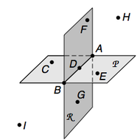

- Use the above figure to answer the following questions.

  - What is the intersection of plane P and plane R?

  - Name three points that are collinear

  - Name plane R in two more ways

  - Name four coplanar points

  - Name a point that lies on both plane P and plane R

- To the nearest tenth, find the perimeter of ∆ABC with vertices A(-1,4), B(-2,1) and C(2,1). Show your work.

- Use the figure to complete each statement. 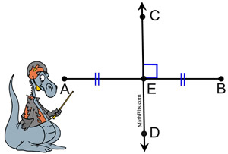
  - m<BED = ______
  - CD is the _______of AB
  - AE = ½ ______
  - If AB = 18, then EB = _____
  - ____ is the midpoint of _____

- If AB = 58, find the value of x. Show your work.

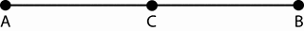
3x - 6 2x + 4

- Write a conditional statement. Write the converse, inverse and contrapositive for your statement and determine the truth value of each. If a statement’s truth value is false, give a counterexample.

- Name two pairs of congruent angles and justify your answer.

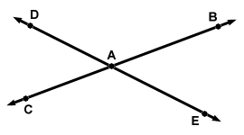

- Write a two-column proof
Given: `
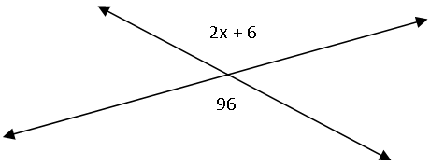
Prove: x = 45

- Find the measure of the third angle of a triangle given that the first two angles are 44º and 72 º. Show your work.

- Write a congruence statement for the pair of triangles

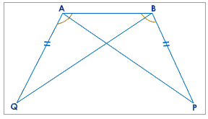

- Find the values of x and y. Show your work.
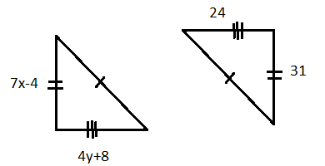

- Which postulate or theorem, if any, could be used to prove the triangles congruent? If not enough information is given, write not enough information.

- 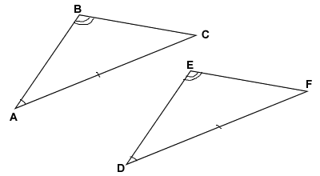

- 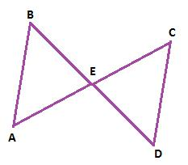

- 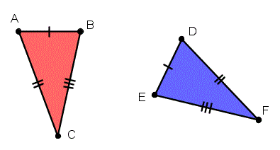

- 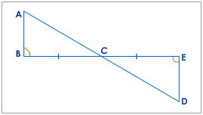

- List the sides of each triangle from shortest to greatest
  - 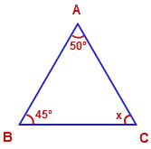
  - 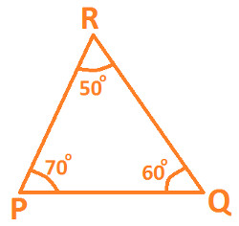

- If AB is the midsegment, find the value of x. Show your work.
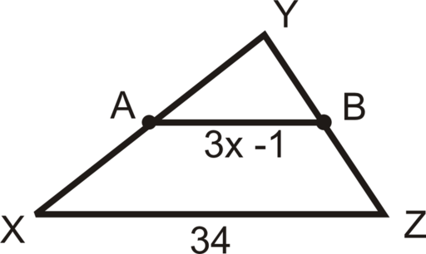

- Find the coordinates of the circumcenter for ∆DEF with coordinates D(1,3) E (8,3) and F(1,-5). Show your work.

- In triangle ∆PQR, C is the centroid.

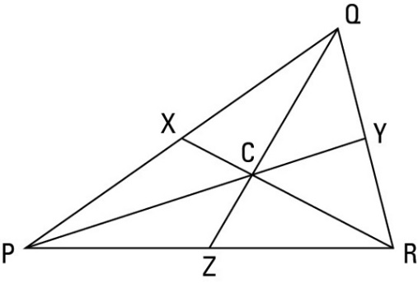

  - If PX = 25, find PQ

- If CY = 9, find PC and PY

- If QC = 12, find ZC and ZQ

- For quadrilateral ABCD, determine the most precise name for it. A(-2,3), B (9,3), C(5,6) and D(2,6). Show your work and explain.

- For the parallelogram, find the value of the variables. Show your work.

5x + 2

3y - 6 21

17

- What is the length of the 2nd base of a trapezoid if the length of one base is 27 and the length of the midsegment is 19? Show your work.

- What is the sum of the measures of the exterior angles in a nonagon? Explain.

- Find the measure of each interior angle AND each exterior angles of the following regular polygons. Show your work.

  - Pentagon

- 16-gon

- Dodecagon

